MATT TAYLOR 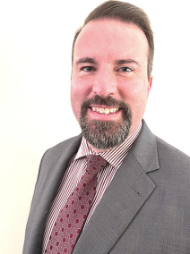

United States Air Force Officer - Keynote Speaker - Corporate Trainer

ABOUT ME

Matt Taylor is a renowned public speaking expert, coach, and trainer. After being inspired by the commissioner at his first agency staff meeting, Matt has dedicated his career to helping individuals and organizations master the art of public speaking and communication. Matt's job involves delivering presentations to agency leadership, but he has also gained an enjoyment for the art.

Matt is a member of Toastmasters and Toastmasters opened the door for him to consider public speaking as a profession instead of just an extra-curricular activity. Matt is also a Category Manager for the State of Georgia.

With over 12 years of experience as a professional speaker, Matt has delivered countless speeches to audiences of all sizes, from small business teams to large-scale conferences. His dynamic speaking style and engaging personality have captivated audiences around the country.

As a trainer and coach, Matt has helped countless individuals and organizations improve their communication skills and achieve their goals. He is known for his personalized approach, tailoring his coaching to each individual's unique needs and goals.

Matt is passionate about empowering others to become confident, effective communicators. He believes that anyone can become a great public speaker with the right training and support. His keynote speeches are both inspiring and informative, providing practical tips and strategies that attendees can immediately apply to their own speaking engagements.

If you're looking to improve your public speaking skills, or you're simply looking for an engaging and informative keynote speaker, Matt Taylor is the perfect choice. His expertise and passion for communication are sure to leave a lasting impact on your audience.

Matt has lived in Georgia most of his life and has earned his Bachelor's Degree from the University of Georgia, and his Master's Degree from SUNY at Rome/Utica and he served 7 years in the US Air Force.

SPEAKING

TOPICS

SPEAKING TOPIC 1

How to Overcome the Fear of Public Speaking

SPEAKING TOPIC 2 How to Do a Successful Interview

SPEAKING TOPIC 3

Customized Topics Are Also

Available

AVAILABLE FOR

Keynote Presentations Breakout Rooms

Virtual Events

Corporate Workshops Group Coaching

Leadership Seminars Expert Interviews

Book Mat ! 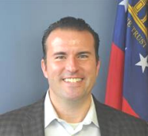

Matt.Taylor@doas.ga.gov

linkedin.com/in/matthew-taylor